

HEALTH MONITORInGAND DIAGNOSIS

DEPARTMENT OF COMPUTER SCIENCE AND ENGINEERING

BY

T.VIGNESH

REG NO-815522104303

Abstract:

* Nowadays Health-care Environment has developed science and knowledge based on Wireless-Sensing node Technology oriented. Patients are facing a problematic situation of unforeseen demise due to the specific reason of heart problems and attack which is because of nonexistence of good medical maintenance to patients at the needed time.
* To track the patient health micro-controller is in turn interfaced to an LCD display and wi-fi connection to send the data to the web-server (wireless sensing node).
* Introduction:
* According to the constitutions of World Health Organization (WHO) the highest attainable standard of health is a fundamental right for an individual.
* health tracking system that uses sensors to track patient vital parameters and uses internet to update the doctors so that they can help in case of any issues at the earliest preventing death rates.

BLOCK DIAGRAM:

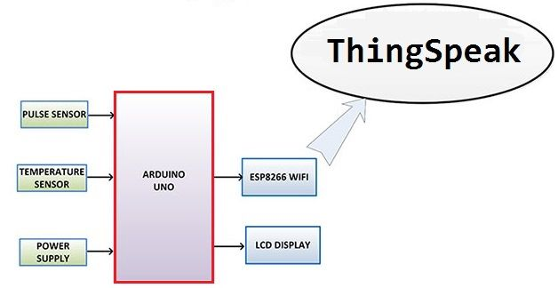

HARDWARE REQUIREMENTS

● Arduino

● Temperature Sensor

● Pulse Sensor

● WIfi Module

● IOT Module

● Power Supply ● Connecting Cable

SOFTWARE REQUIREMENTS

● Arduino IDE

● Language: C

● ThingSpeak (IOT Cloud Server)